Chapter 9, Solution 55.
-j4 

I
I₁
j8 

12 
Z
+
−
I₂
-j20 V
+
V_{o}
−
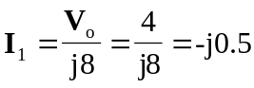
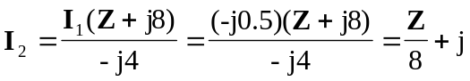
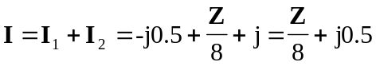
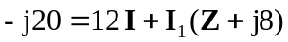
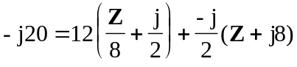
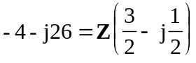
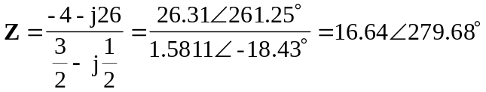

Z = (2.798 – j16.403) 

